**MCA**

**PROJECT BASED LEARNING A.Y. 2023 - 2024**

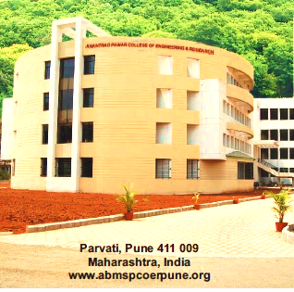

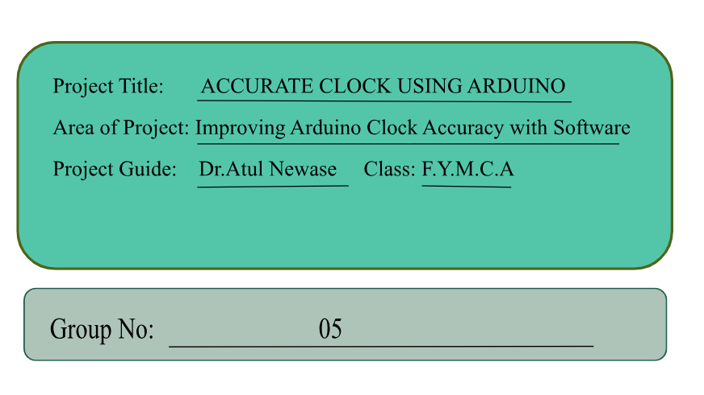







**A.B.M.S.PARISHAD’S**

**ANANTRAO PAWAR COLLEGE**

**OF ENGINEERING & RESEARCH**

**Parvati, Pune-09**

**NAAC A Accredited Institute**

**A Project**

**On**

**ACCURATE CLOCK USING ARDUINO**

**SUBMITTED IN FULFILLMENT FOR SUBMISSION**

**OF**

**Project Based Learning-I**

**MASTER OF COMPUTER APPLICATION**

**SUBMITTED BY**

**BANDAGAR MALASHRI Exam No: 6592**

**GAWADE SHIVAM Exam No: 6612**

**PRATHAMESH HABIB Exam No: 6649**

**Under the guidance of**

DR.ATUL NEWASE

**Department of Master of Computer Application**

**SAVITRIBAI PHULE PUNE**

**UNIVERSITY**

**2023-24**

 **A.B.M.S.PARISHAD’S**

**ANANTRAO PAWAR COLLEGE**

**OF ENGINEERING & RESEARCH**

Parvati, Pune-09

**NAAC Accredited Institute**

**Department of Master Of Computer Application**

***CERTIFICATE***

This is to certify that the project report entitled

**“PROJECT TITLE.”**

Submitted by

**BANDAGAR MALASHRI Exam No: 6592**

**GAWADE SHIVAM Exam No: 6612**

**PRATHAMESH HABIB Exam No: 6649**

is a bonafide student of this institute and the work has been carried out by him/her under the supervision of **Dr. Atul Newase** and it is approved for the partial fulfillment of the requirement of Savitribai Phule Pune University, for the award of the degree of **Master of Computer Application**.

Place: Pune

Date: / /

**Prof.Atul Newase Prof. Nishant S Rathod Dr. Atul D Newase**

**PBL Project Guide PBL Coordinator MCA Coordinator**

**Rules & Regulations**

|  |
| --- |
| 1. All students must enter the correct information in the Project Diary 2. All the entries in the Project Diary must be verified by the concerned project guide. 3. Students must report to their respective guide on project day as per the time table. 4. Activity planned should be completed as per the schedule only. 5. Students must submit soft and hard copies of the Synopsis and Mini and Major project reports in respective Terms as per the prescribed format. 6. Students must submit and Publish/Present technical papers in the National/International conferences/Journals. 7. Students shall participate in project competitions organized by other reputed Organization/Institute. 8. Students must attach all the Published Papers/Project Competition Certificates in the Final Project Report. 9. Students must carry the Project Diary at the time of meeting with guide, project reviews and examination. 10. For any queries, please contact your project guide/ project coordinator. 11. Project Diary must be submitted to Project Coordinator at the time of Project Examination. |
| **Project Report Structure:**   1. Title Page:-Mention Title of the report along with name of project group, Guide, Department, Month and Year of submission. 2. Certificate: - Signed by the Guide. The certificate should mentioned that the work has been carried out by this project group and has not been submitted by any other group of the institute for the award of any other degree 3. Declaration of novelty and originality. 4. Acknowledgement 5. Abstract is a precise version of the project report. It should be limited to a maximum of 250 words (introduction, problem statement, procedures, results, and conclusion) 6. Table of Contents, List of Tables, List of Figures, List of abbreviations, List of Symbols, 7. Main Body of Report consisting of Introduction, Literature Survey, problem statement, Methodology, Analysis, Validation, Results and Discussion, and Conclusion. 8. References in the standard format.(Refer SPPU Syllabus/IEEE/Elsevier/Scopus Indexed Journals) 9. Appendix (Datasheets, Standard Tables, Publication Credentials, etc.) |

**Project Group Information**

|  |  |  |  |  |
| --- | --- | --- | --- | --- |
| **Sr. No.** | **Photo** | **Name** | **Personal Details** | **Sign.** |
|  |  | BANDAGAR  MALASHRI | Roll No:3505  Exam Seat No:6592  Mobile No:7264924769  Email ID:bandgar.malashri@gmail.com |  |
|  |  | GAWADE  SHIVAM | Roll No:3534  Exam Seat No:  Mobile No:7350479575  Email ID:shivamgawade8888@gmail.com |  |
|  |  | HABIB  PRATHAMESH | Roll No:3538  Exam Seat No:6649  Mobile No:7030375737  Email ID:prathameshhabib2104@gmail.com |  |

**UNDERTAKING BY STUDENTS**

We, the students of MCA. Bandagar Malashri, Gawade Shivam and Habib Prathamesh are hereby assured that we will follow all the rules and regulations of SavitribaiPhule Pune University related to the project work for the academic year 2023-2024.

The Project entitled-

 Accurate Clock Using Arduino

will be designed and developed by us and no part of the project will be designed/developed by any external entity or copied from some external resources. We are fully aware that copying or taking help of any external agency in the development of our project is unethical and illegal. The Examiners /University can initiate an action against us as per SavitribaiPhule Pune University norms if found violation of rules and regulations.

|  |  |  |  |
| --- | --- | --- | --- |
| **Sr. No.** | **Roll No.** | **Name of Student** | **Signature** |
| 1 | 3505 | Bandagar Malashri |  |
| 2 | 3534 | Gawade Shivam |  |
| 3 | 3538 | Habib Prathamesh |  |

**Project Plan**

|  |  |  |  |  |
| --- | --- | --- | --- | --- |
| **Sr. No.** | **Project Activity** | **Description** | **Date Of Completion** | **Sign of**  **Guide** |
| 1. | Project Overview | Developed a clear understanding of the project goals and objectives | 15/02/2024 |  |
| 2. | Planned and Features | Identified and prioritized the key functionalities and requirements of the Accurate Clock. | 27/02/2024 |  |
| 3. | Procured Project Hardware | Acquired the necessary components such as Arduino Nano, I2C module, etc. | 02/03/2024 |  |
|  | Build the Hardware | Assembled the acquired components together | 15/03/2024 |  |
| 5. | Write the Software | Create the code to enable button responses and execute specific actions | 25/03/2024 |  |
| 6. | Test and Debug | Thoroughly test the door unlock system functionality. Verify that it’s working Properly. | 02/03/2024 |  |
| 7. | Finalize and Share | Review the completed work, make any necessary refinements based on testing and debugging results, and submit the finalized project. | 10/04/2024 |  |

**Library Visit Record**

|  |  |  |  |
| --- | --- | --- | --- |
| **Sr. No.** | **Date** | **Used** | **Sign of Librarian** |
| 1 | 24/02/2024 | Arduino Project Handbook |  |
| 2 | 02/03/2024 | Arduino Book for beginners |  |
| 3 | 09/03/2024 | Basic Arduino Projects |  |
| 4 | 24/03/2024 | Standard Methods for Arduino Clock |  |

**Project Review- I Details**

|  |  |  |  |
| --- | --- | --- | --- |
| **Sr. No.** | **Roll No.** | **Name of Student** | **Signature** |
|  | 3505 | Bandagar Malashri |  |
|  | 3534 | Gawade Shivam |  |
|  | 3634 | Habib Prathamesh |  |

|  |
| --- |
| **Project Progress:** |

|  |
| --- |
| **Comments by Guide:** |

|  |  |
| --- | --- |
| **Date:** |  |
| **Guide Project Coordinator** | **Head of the Department** |

**Project Review- II Details**

|  |  |  |  |
| --- | --- | --- | --- |
| **Sr. No.** | **Roll No.** | **Name of Student** | **Signature** |
|  | 3505 | Bandagar Malashri |  |
|  | 3534 | Gawade Shivam |  |
|  | 3538 | Habib Prathamesh |  |

|  |
| --- |
| **Project Progress:** |

|  |
| --- |
| **Comments by Guide:** |

|  |  |
| --- | --- |
| **Date:** |  |
| **Guide Project Coordinator** | **Head of the Department** |

**Project Review Approval sheet by Guide**

|  |  |  |  |  |
| --- | --- | --- | --- | --- |
| **Review Number** | **Date of Review** | **Comment** | **Approval for Project Review (y/N)** | **Sign of Guide** |
| **1** | 06/04/2024 | Begin by providing an overview comment at beginning of this project file , explanning the purpose of project , its components & they work together well | YES |  |
| **2** | 26/04/2026 | All compents are attached but to avoid some glites to work project properly | YES |  |
| **3** |  |  |  |  |

**Project Reviews (Reviewers)**

|  |  |  |  |  |
| --- | --- | --- | --- | --- |
| **Sr. No.** | **Date of Review** | **Name of Reviewer** | **Sign of Reviewer** | **Comments** |
| 1 | 06/04/2024 | Prof. Priyanka Tadake |  | Overall, your project demonstrates creativity, technical competence, and attention to detail. Keep up the excellent work, and don’t hesitate to reach out if you need further guidance or assistance. Well done |
| Prof.Bhagyashri Tupere |  |
| 2 | 26/04/2024 | Prof. Priyanka Tadake |  | Evaluate the efficiency of the code and suggest optimization where possible .this could include unnecessary computations & improving compexcity06/04/2024 |
| Prof.Bhagyashri Tupere |  |
| 3 |  |  |  |  |
|  |  |

**Action Plan After Review by Guide**

|  |  |  |  |
| --- | --- | --- | --- |
| **Review**  **No.** | **Date of Review** | **Remark by Guide** | **Guide Signature** |
| 1 | 06/04/2024 | Implement suggested changes regarding circuit design to optimize efficiency. Revise code logic to enhance readability and maintainability. Incorporate additional error handling mechanisms as advised. |  |
| 2 | 26/04/2024 | Evaluate the efficiency of the code and suggest optimization where possible .this could include unnecessary computations & improving compexcity |  |
| 3 |  |  |  |
| 4 |  |  |  |
| 5 |  |  |  |

**Cost Estimation**

|  |  |  |
| --- | --- | --- |
| **Sr. No.** | **Particular** | **Amount in Rupees** |
| 1. | Arduino Nano board | 500 |
| 2. | Tactile Switch, Top Actuated | 120 |
| 3. | Alphanumeric LCD, 16 x 2 | 300 |
| 5. | Buzzer | 65 |
| 6. | Trimmer Potentiometer, 10k | 35 |
| 7. | UNO LiquidCrystal I2c | 80 |
| 9. | Relay | 80 |
| 10. | Battery | 35 |
| 11. | Connecting Wires | 80 |
| 12. | BreadBoard | 200 |
|  | Total | 1500 |

**References**

|  |  |
| --- | --- |
| **Sr. No.** | **E-Book / E-Journals / Ieee Journals / Conference Paper Referred** |
| 1. | “Arduino Cookbook” by Michael Margolis |
| 2. | “Arduino Project Handbook: Volume 1” by Mark Geddes |
| 3. | “Arduino Workshop: A Hands-On Introduction with 65 Projects” by John Boxall |
| 4. | Canto, R., Bufalari, I., & D'Ausilio, A. (2011). A convenient and accurate parallel |
| 5. | MacInnes, W. J., & Taylor, T. L. (2001). Millisecond timing accuracy on PCs and Macs. |